**S3 Practical 22 Aug 2024**

1. Create two user having S3Readonly access

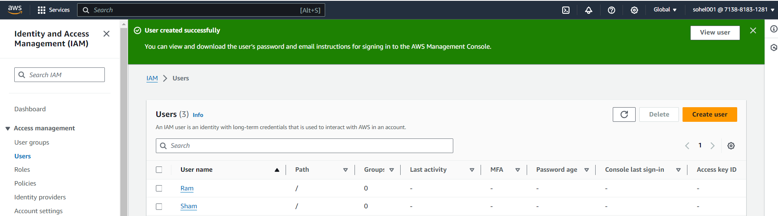

1. Created one bucket

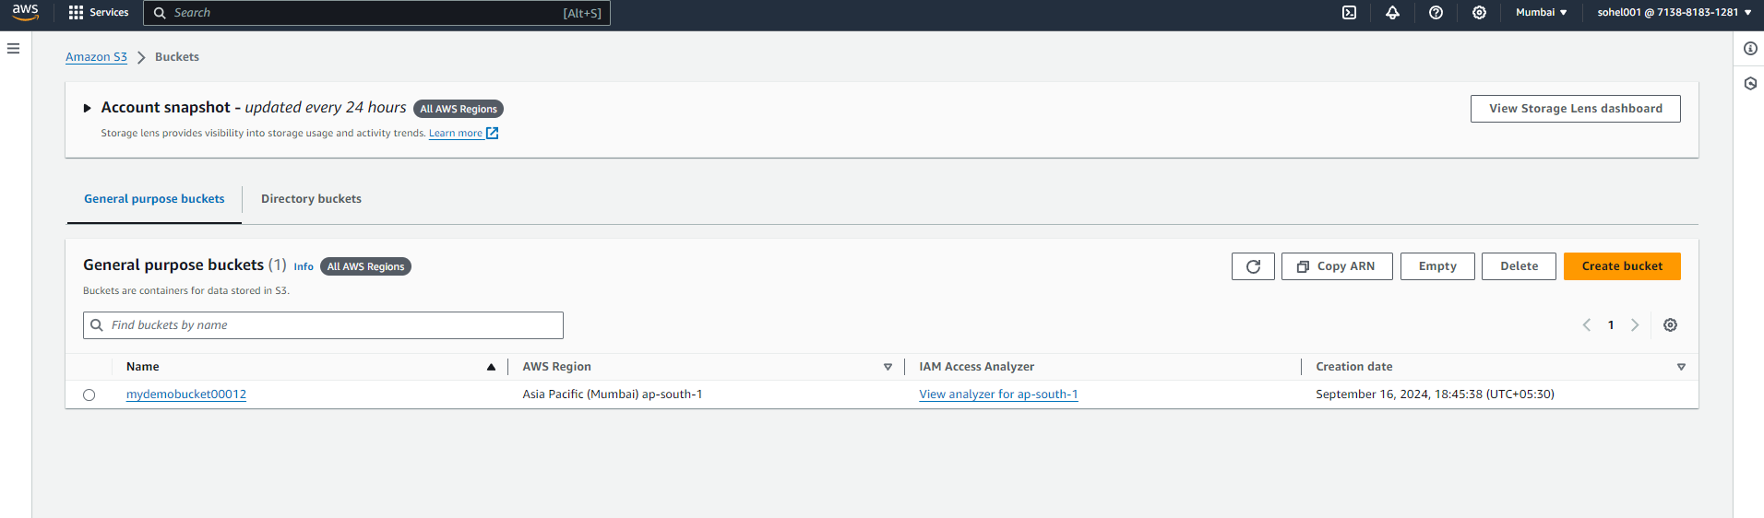

1. Goto the bucket policy and click edit button it will open and click on policy generatior.

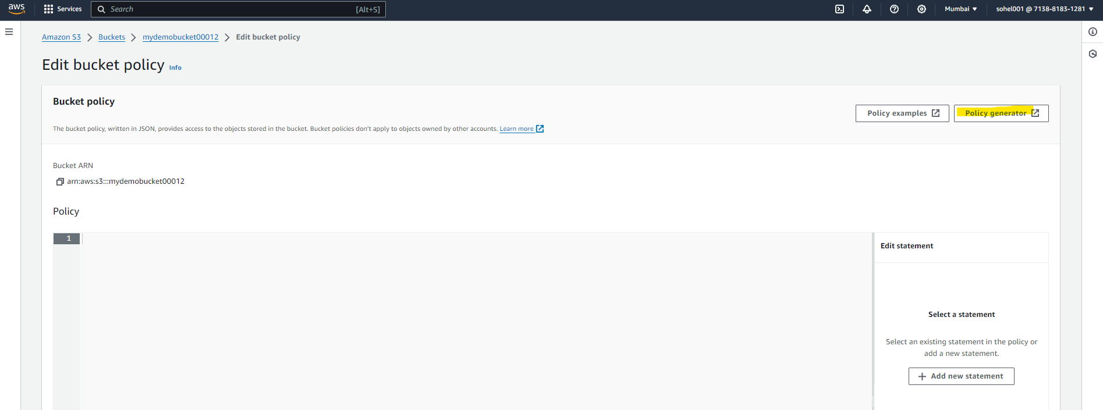

1. We have given policy for Ram User it will generate

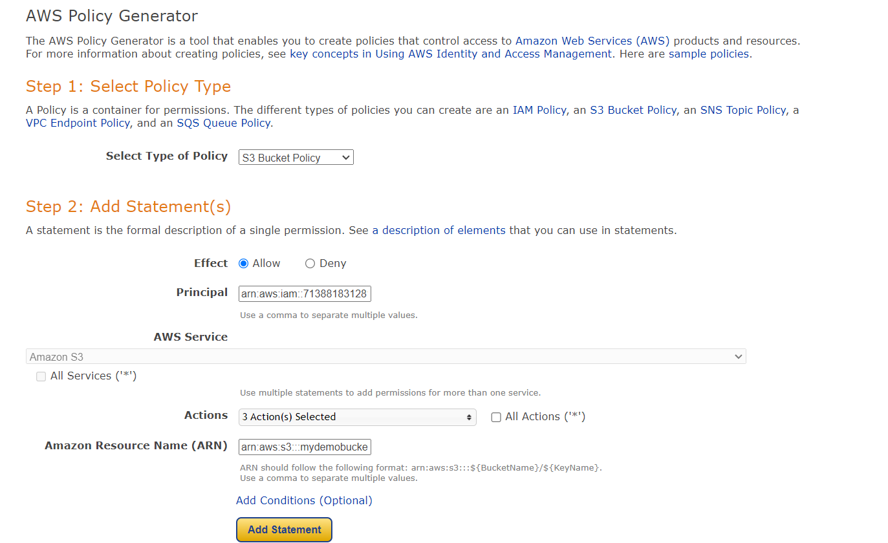

1. Policy is ready
2. 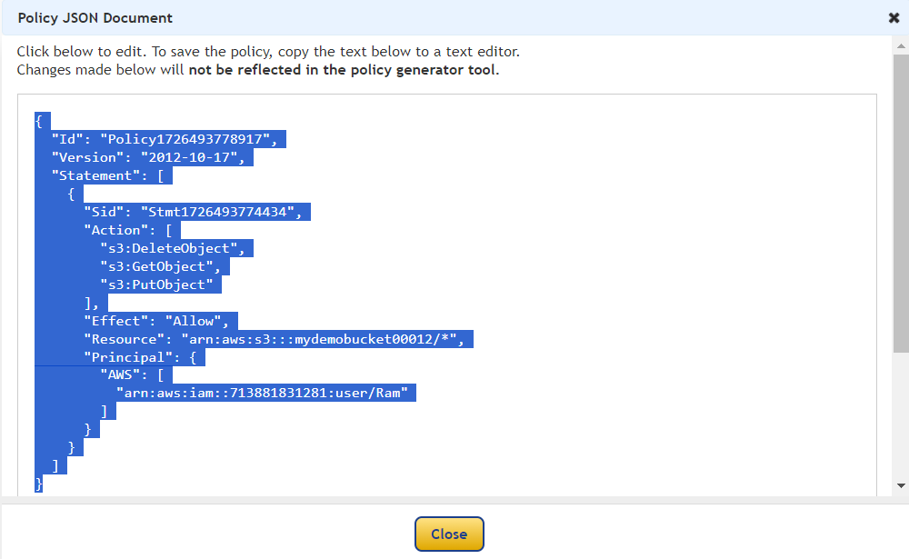
3. Post the code in bucket and save it

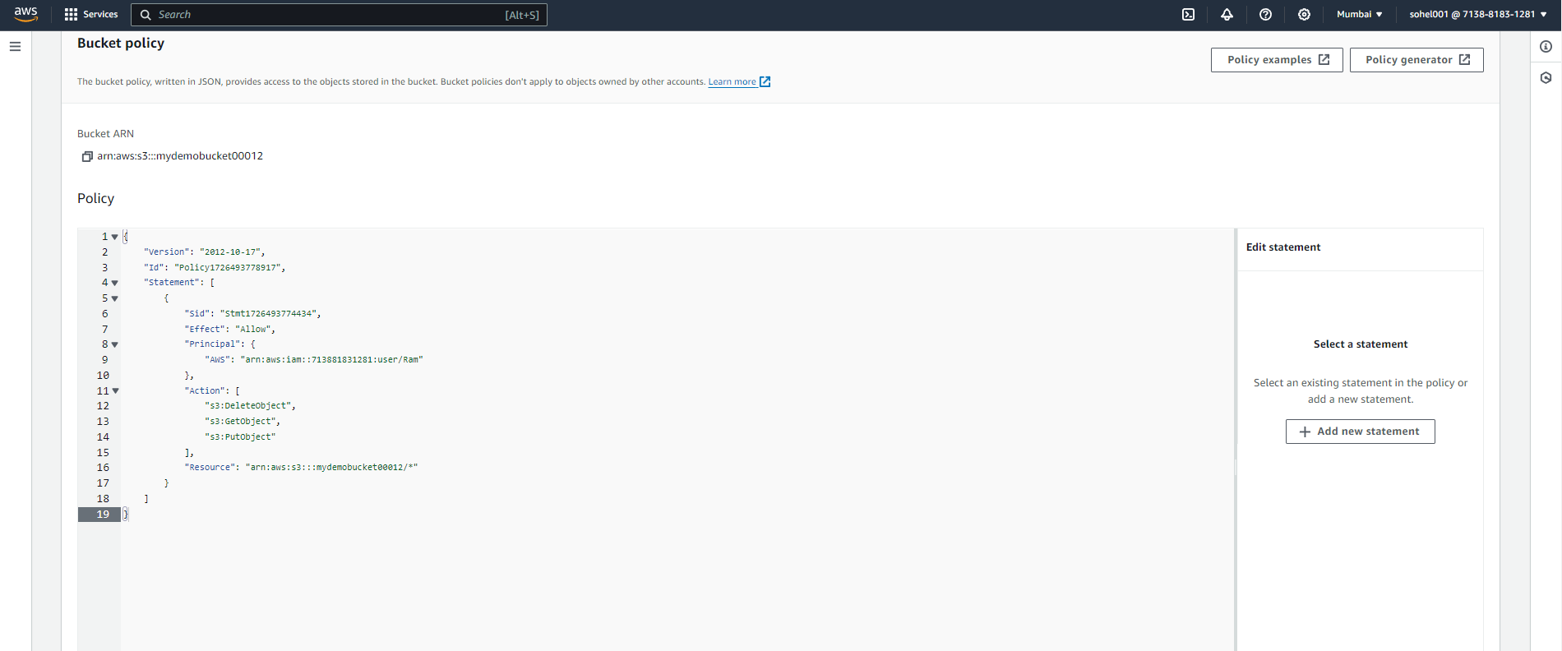

1. Now,
2. trying to get console for Sham user and creating bucket it wont able to create.

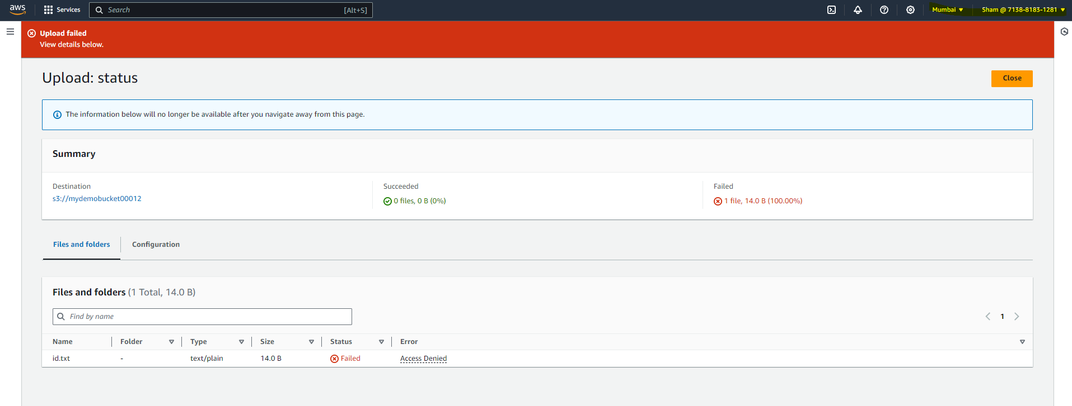

1. Trying to deleted the existing bucket it wont

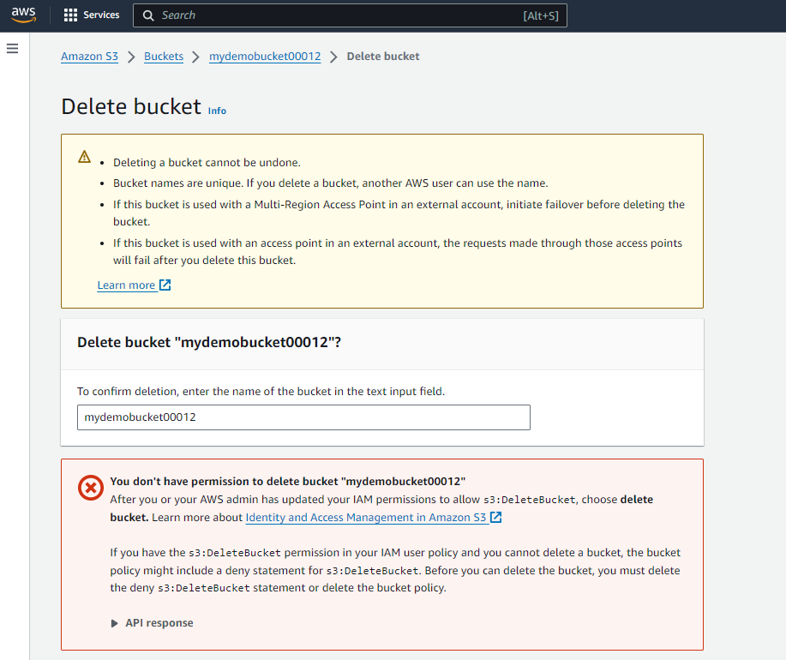

C.That means we can not add or delete the object in bucket when user having S3Read only access.

1. Now login with Ram which we provide policy.
2. We can add the object

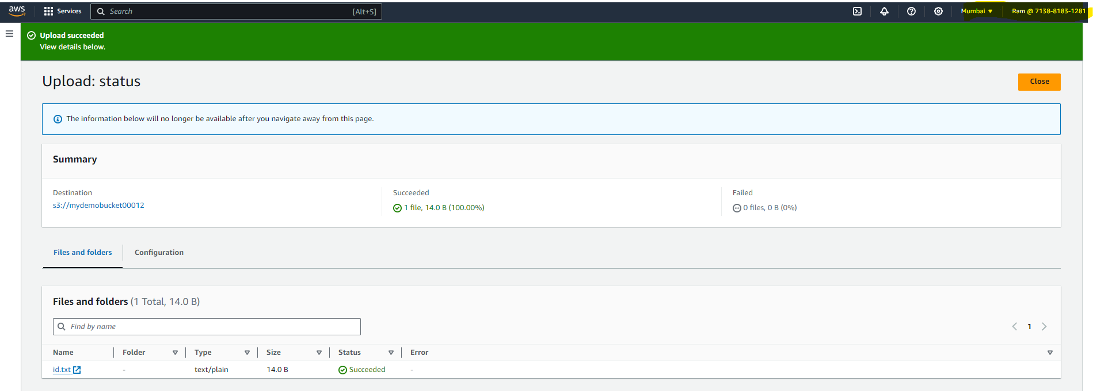

1. We can delete the object.

